BRIAN R. TOUNG 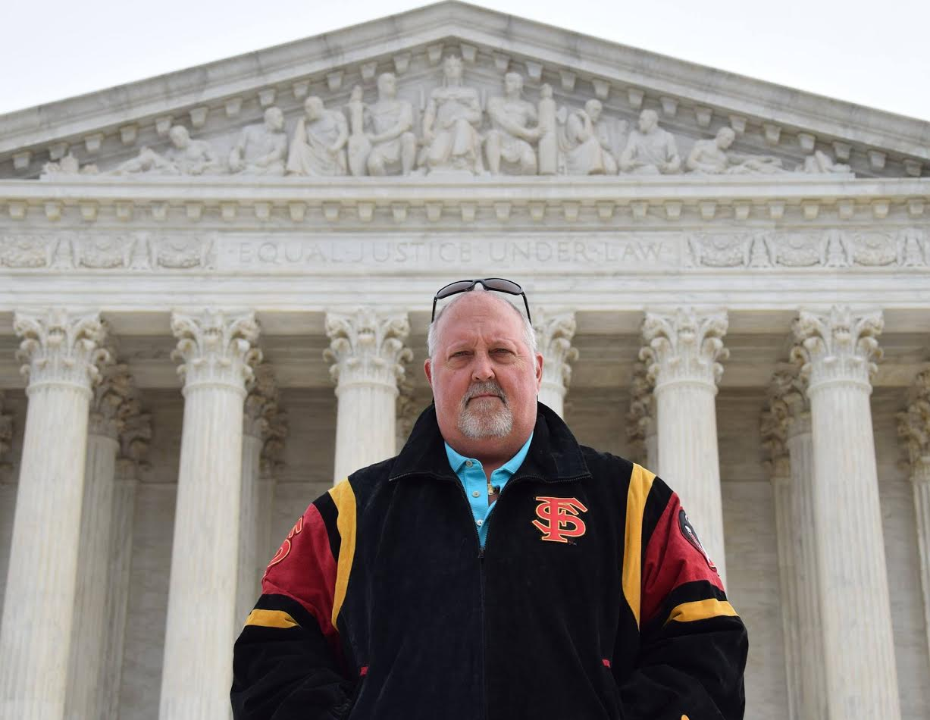
brtoung@gmail.com
Home: 758 Pelican Bay Drive
Daytona Beach, FL 32119
(386) 255-3425
Cell (386)290-4624
Web: www.briantoung.com
EDUCATION:

Post Doc Embry-Riddle Aeronautical University, Worldwide, Daytona Beach, Fl Master
of Aeronautical Science, Specializations; Dual majors in Aviation Education Technology and Aviation Safety; With Distinction; GPA 4.0, MS December, 2010.

Doc University and College of Natural Health: PhD (2) in Holistic Natural Health and Nutrition and Holistic Sports Nutrition and Physiology, Spring 2015 Summa Cum Laude with Superior Distinction (GPA 4.0).

Legal: JURIS DOCTOR, JD: Florida State University College of Law, Tallahassee, Fl., April 1983, With Cum Laude Honors.
Activities: President, Student Bar Assoc., fall 1982 Secretary, SBA, spring 1982; Player\Coach Law School Champion Football and Softball teams, Faculty
Appointments Committee, Phi Delta Phi legal Fraternity.

Special Studies: Summer Program in Law; Oxford University, St. Edmunds Hall, Oxford England, 1982

Undergrad: BACHELOR OF SCIENCE: Auburn University, Auburn, Alabama, June 1980, With High Honors; Magna Cum Laude GPA 3.65
MAJOR: Business Administration\Finance
HONORS: Deans list x 6, Made 4.0 with 26 hours fall of 1979, Beta Gamma Sigma Business Honorary.
ACTIVITIES: Finance Club, Pre-Law Society, Delta Sigma Pi Business Fraternity, Pre-College Counseling Orientation Leader, Skydiving Team, Flight School, earned Private Pilot's in license 1978 at age 20.

WORK EXPERIENCE:

ATTORNEY:

BRIAN R. TOUNG, P.A., formed October 1, 1990. In association with NIXON & TOUNG, an A.V. Martindale rated partnership of P.A.'s Jan. 1, 1992 to September 25, 1998; 619 N. Grandview Ave. Daytona Beach, Florida 32118. Specializing in Plaintiff's Personal Injury, Business, Aviation, and Commercial litigation, Real Estate matters, and Criminal Defense. In sole practice September 25, 1998 to present at 213 Silver Beach Ave., Daytona Beach Fl 32118 until July, 2006. Moved to 947 Beville Rd. S. Daytona Ste. 14, FL July 2006 to present.

RICE, ROSE & TOUNG, a partnership formed Jan. 1, 1990 and dissolved September 28, 1990. 20 No. Halifax Ave., Daytona Beach, Florida, 32118. Full service Criminal and Civil practice.

LANDIS, GRAHAM, FRENCH, HUSFELD, SHERMAN & FORD, P.A. 543 S. Ridgewood Ave., Daytona Beach, Fla. 32115. June 22, 1987 to Dec 31, 1989. Represented State Farm Mutual Auto Ins. Co. and other insurance defense as well as general civil litigation.

HAAS, BOEHM, BROWN, RIGDON, SEACREST & FISCHER, P.A. 654 S. Ridgewood Ave., Daytona Beach, Florida, 32115.August 15, 1983 to June 8, 1987. Specialized in Insurance Defense at both trial and appellate levels, and both state and federal courts.

COLLEGE ADJUNCT:

Embry Riddle Aeronautical University; Worldwide. Taught ASCI 254; Aviation Legislation Spring 2011 – Present Online. MGMT 390 Business Law, 2013. Promoted to Adjunct Assistant Professor, January 2014 to present.
Embry-Riddle Aeronautical University; Daytona Beach, FL. Taught ASC-402 Aviation Law; Spring, 2007, Flight Ground School ASC 121 and Aeronautical Science Success ASC 101 Fall, 2008, in classroom.
University of Central Florida; Daytona Beach Campus 1988-1992 Taught upper level business law course; Legal Environment of Business, in classroom.

LAW CLERK:

THE FLORIDA BAR; Appallachee Pky., Tallahassee, Florida. January 1983 to August 1983. Clerk to Branch staff Counsel, Lawyer Regulation Division.

ROBERTS, BAGGETT, LAFACE, RICHARD & WISER, P.A. 101 E. College Ave., Tallahassee, Fl. September 1982 to Dec. 1982. Clerk to former Chief Justice B.K. Roberts

LEGISLATIVE INTERN: FLORIDA HOUSE OF REPRESENTATIVES, Committee on
Tourism and Economic Development. Chairman, Bob Crawford, Winter Haven, Florida. September 1981 to June 1982. Assisted in developing Florida Real Estate Commission bill and Department of Professional Regulation legislation.

ASSOCIATIONS & ADMISSIONS:

Admitted to the Florida Bar, October 26, 1983; Supreme Court of U.S. 1988; 11th Circuit Court of Appeals, 1985; Federal Trial Court, Middle District of Florida, 1984; Phi Delta Phi Legal Frat; Assoc. of Trial Lawyers of America and ABA, 1983-90; Volusia Co. Bar Assoc, Treasurer 1989-90; Defense Research Institute 1983-90, Academy of FL Trial Lawyers; Board Certified by Florida Bar, Civil Trial, June 1988 to present, and by the National Board of Trial Advocacy, Dec. 1989; Elected to 7th Circuit Young Lawyer Division Board of Governors, 1987 to 1991, Chairman, Robert Orseck Moot Court Competition 1988-1991; Vol. Co. FSU Boosters, President 1992; President, Uptown Daytona Kiwanis Club 1989-1990; member Vol. Co. Civil and Criminal Trial Lawyers Associations; Daytona Beach and Port Orange Chamber of Commerce, Port Orange South Daytona Chamber of Commerce Board, 2010-2018, Chairman 2017, USGA, Daytona Beach Exec.Assoc. 1990; 7th Judicial Cir. Judicial Nominating Comm., 1990-1993; 7th Cir. Grievance Committee 7A, 1990 to 1993, Chairman 1992-1993; and 2013-2017, Co-Chair 2017; Volusia County Bar Association Ethics Committee, 1992 to date; Southern Trial Lawyers Assoc., Certified Mediator by Florida Supreme Court # 4675R 1993, 2018. Lawyer-Pilot's Bar Association. Member James Publishing Company, Editorial Board. Member, Million Dollar Advocates Forum. Board member Port Orange/S. Daytona Chamber of commerce 2010-2013, Vice President Govt. and Economic Development 2015-2016, Chairman of the Board, Nov, 2016-2017. National Trial Lawyers, Top 100, Criminal Defense, 2016.

CLIENTS: (Past and present)

GM, State Farm Ins., AIG, Nava Moto SPA of Italy, Kentucky Fried Chicken, Milemarker Inc., Winn Dixie Stores, Votran Bus Service, Volusia and Flagler County School Boards, Cincinnati Ins., Police Benevolent Association, Hartford Ins., Aetna, Moore Group, Progressive Ins., Re-Max Realty, Watson Ins. Agency, Mitchell Noel, Tumblin Ins. PBA, Metra, Inc., and hundreds of small businesses, corporations and individuals in civil and criminal cases.

CONTINUING LEGAL EDUCATION since 1988

-Fourth Engineering and Medical Institute for Attorneys; Sponsored by the University of Miami
-Advanced Evidence; Sponsored by FTLA; Tampa FL.
-The Best of 88; Sponsored by Academy of Fla. Trial Lawyers; Aspen, Colorado.
-Advanced Trial Advocacy; Sponsored by the Florida Bar; Gainesville, FL
-Workhorse Seminar; Sponsored by the Academy of Florida Trial Lawyers; Orlando, Fl.
-Medical-Legal Seminar; Sponsored by Volusia County Civil Trial Attorneys; Telluride, CO
-The Masters in Trial; Sponsored by the American Board of Trial Advocates; Jacksonville -American Arbitration Association Mediation Training; 40 hour course, Tampa.
-Masters In Trial; Sponsored by the American Board of Trial Advocate; Jacksonville, Fl
-1998 Workhorse Seminar: AFTL; Orlando Renaissance
-FACDL; Blood Sweat and Tears DUI seminar; Lake Buena Vista Palace
-AFTL: Auto Negligence
-AFTL: Workhorse Seminar; Orlando Caribe Royale
-AFTL: Advanced Trial Skills
-Lawyer Pilots Bar Assn: Winter meeting; San Antonio
-Ethics Review at Civil Trial Lawyers Meeting
-Lawyers Pilots Bar Assn; Winter meeting Orlando
-Advanced Jury Selection; Academy of Florida Trial Lawyers; Tampa Marriott
-Lawyer-Pilots Bar Assn. Winter Meeting; Lucaya Bahamas
-Lawyer-Pilots Bar Assn. Winter Meeting Feb 2006; Fernandina Amelia Is
-NTSB Bar Assn; Blue Angels; LPBA Meeting Nov 2006; Pensacola, FL
-Lawyer-Pilots Bar Assn; Summer Meeting July 2007 Park City, Utah
-NTSB Bar Assn; LPBA Nov 2010 Washington, DC
-Lawyer-Pilots Bar Assn; Summer Meeting July 2012 Williamsburg, Virginia
-Southern Methodist University 50th annual law symposium, 2015 Dallas
-International Transportation and Safety Bar Association annual seminar 2017 Seattle
-Circuit Civil Mediation Training Eric Dunlap completed 8/5/18 Orlando

TRIAL EXPERIENCE: (as of 1/2/19) Total Jury Trials 57

Circuit Civil 45 (tried to verdict by Jury 25-16-4)
Criminal 1 (1-0) Felony jury trial
Circuit Civil 9 (tried to verdict non-jury 7-0-1)
Total 53
County Civil; Jury Trials; 1 W
County Civil; Non Jury Trials 22
County Criminal; Jury Trials 10 (7-3)
County Criminal Non-jury: 2-1

APPELLATE:
5TH District Court of Appeals; Daytona Beach;
Lintello v. Skydive Deland (argued 11/4/08)
Whittington v. Laney, 566 So2d 599
Auto Owners v. Brockman, 524 So2d 490
Young v. Shelton's T.V., PCA, no opinion
Lemen v. FPL, 452 So2d 1107
Evans v. American Processing, PCA, no op

11th Circuit Court of Appeals: Atlanta
Dykes v. Hoseman, 743 F.2d 1488
776 F.2d 942 (petition for rehearing)
783 F.2d 1000 (reh. en banc)
U.S. Supreme Ct. denied Cert.

LARGEST VERDICTS/SETTLEMENTS AS PLAINTIFF’S COUNSEL:

1992 Williams vs. Bethune Cookman College V $ 2,548,091.00
2008 Coluccio v. Cancun Lagoon S $ 1,850,000.00
2002 Tolen v. Attarain S $ 1,400,000.00
2000 Barber v. Chrysler S $ 1,215,000.00
1991 Wallace vs. Palumbo V $ 992,000.00
2018 Phillips v. Allstate S $ 540,000.00
2008 Whitney v. E.B Trucking LLC S $ 425,000.00
2016 Anderson v. Bike and Build S $ 350,000.00
2004 Cox v. Grater V $ 315,000.00
2013 Daniluk v. Nagrani S $ 255,000.00
2004 Smith v. Allstate S $ 250,000.00
1992 Capolupo vs. Chisolm V $ 204,676.00
1994 Evans vs. American Processing V $ 201,750.00
2018 Jamieson v. Progressive S $ 140,000.00

LECTURES:

Adjunct Lecturer; Embry-Riddle Aeronautical University; Spring 2007 Aviation Law, Fall 2008 Private Pilot Ground, College Success

Nov. 23, 1992; University of Arizona, Tucson. Topic: "Alternative Dispute resolution" to two sections of Organizational Communication, junior level; 500 students, and 200 students present.

Adjunct Lecturer; Legal Environment of Business; Required Junior level course offered by UCF School of Accounting; 1987 to 1992.

May 6,2009,Law Week lecture to Three Springs School about the Civil War and Gettysburg Address.

April 30, 2004, Law Week lecture to Mrs. Nielson's 12th grade class at Mainland HS

April 25, 2002, Law Week lecture to Mrs. Buckner's 4th grade class at Horizon Elementary.

May 2, 2000 Law Week lecture to Hurst Elementary School 4th grade students on the legal system and it's function in our town.

April 28, 1993 Law Week Lecture to Spruce Creek Elementary School 5th Grade students on juvenile law.

April 30, 1992 Law Week Lecture to Holly Hill Middle School 5th and 6th grade students on juvenile law.

April 30, 1991 Law Week Lecture to St. Paul Elementary School 6th grade students on juvenile law.

PUBLICATIONS:

Contributing Member of the James' Publishing's Editorial Advisory Board which is Publishing Florida Civil Procedure Before Trial, 1996 Contact Paul S. Amos, Editor, Matthew Grad, Asst. Editor James Publishing Inc. 3520 Cadillac Ave., Suite E Costa Mesa, CA 92626.
Wrote a chapter; “Practice Tips for Plaintiff's personal injury practitioners”.

MEDIATION:

Since 1991, Approx. 300 mediations; certified mediator by the Florida Bar, Cert. # 4675R having received instruction from the American Arbitration Association in May of 1993 in Tampa, FL. Renewed Orlando Eric Dunlap 2018. A list of 10 Florida lawyers who have used me as a mediator is as follows:
Francis Carroll 386-258-3341
Donald Williams 407-426-8184
Daniel Wallace 386-252-1133
David Russell 386-254-2941
Walter Snell 386-255-5334
Brad Hassell 386-238-1357
George Pappas 386-254-2941
Sam Masters 386-252-4717
Leonard Ross 386-547-2732
George Burden 386-258-5069

FLIGHT EXPERIENCE, RATINGS, AND CERTIFICATES:

Flight instruction began in 1977; Age 19
Licensed pilot, Single Engine, Land, May 30, 1978; Auburn University;
Multi-Engine, Land, August 12, 1996;
Instrument Pilot, May 21, 1996;
Commercial Pilot, April 7, 1999;
Certified Flight Instructor, January 6, 2000;
Multi Engine Instructor, April 22, 2000;
CFII, November 5, 2000;
Single Engine, Sea, April 28, 2001
Multi-Engine, Sea, February 5, 2005
Airline Transport Pilot, August 31, 2005, Type Rating Cessna Citation 500 Jet Rating
Certified FAA Ground Instructor, Embry-Riddle Aeronautical Univ., Sept. 2008
Total Flight Hours, 1,980 as of 10/1/17, 406.5 Multi-Engine, 112 Night, 100+ Actual instrument
ICC/BFR: February 6, 2016 BPPP Lakeland
CFI-ASE November 10, 2016, Bob Rasky DFE

OTHER LICENSES:

Licensed Florida Real Estate Broker, IDEA Open Water Scuba Cert, PADI Advanced Open Water Scuba Diver, Class C Sky Diver (330+Jumps as of 1/1/19)
Florida Bar B Que Association, Master Judge, Steak Cook-off Certified Judge, World Food Championships certified judge.

